1.3 Volumes by Revolution: Shell Method
In 1.2 we found that we could compute the volumes of solids or revolution using the washer and disk methods. However, some volume problems are difficult to hand using these methods.

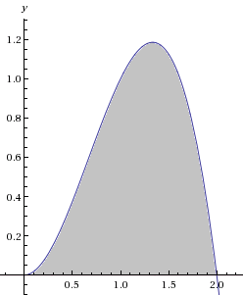
Motivation: Find the volume when the region enclosed by the curves and is rotated about the y-axis.
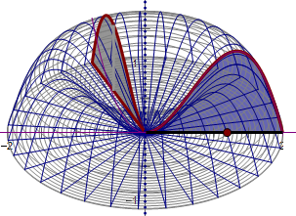
Notice that if we try to compute the area of this figure using washers our integral will have to be in terms of y (since the washers stack up top to bottom and not left to right).

However, solving the equation for x is not easy.

To answer such a question we need to develop a new shape to approximate the volume.

The following link helps to illustrate the Cylindrical Shell Method.
http://mathdemos.org/mathdemos/shellmethod/

Now, let’s see if we can generate a Riemann sum using cylindrical shells instead of disks. Consider the picture below:
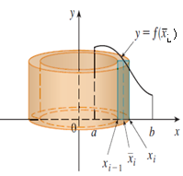
To find a formula for the volume of the cylindrical shell let us subtract the volume of the inner cylinder from the outer cylinder. Notice that we have strategically chosen the sample point in our interval to be .
So, the volume of the shell pictured is:
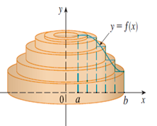
This means that our volume is approximately: . A picture of the approximating shells is below.

To get the volume exactly we take the limit as n goes to infinity: .
We recognize the rightmost sum as a definite integral! Thus, .
Note: Geometrically, x represents the radius of the shell and f(x) represents the height of the shell.
Cylindrical Shell Method

Volume of a Solid of Revolution (w/ a vertical axis of rotation)
If S is a solid that lies between whose volume can be computed using cylindrical shells, then the volume of S is given by
where r is the radius of any cylindrical shell and h is the height of any cylindrical shell. Both r and h are functions of x.

Volume of a Solid of Revolution (w/ a horizontal axis of rotation)
If S is a solid that lies between whose volume can be computed using cylindrical shells, then the volume of S is given by
where r is the radius of any cylindrical shell and h is the height of any cylindrical shell. Both r and h are functions of y.



Example 1: Find the volume when the region enclosed by the curves and is rotated about the y-axis.
$$h$$
$$r$$
$$\left(2,0\right)$$

Since the shells stack up left to right, this problem should be done in terms of x.

Setup:
We can see that and .
Therefore the volume of the solid is given by:

Evaluate:

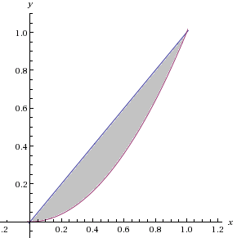
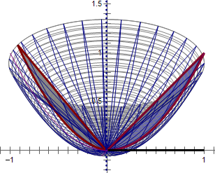
Example 2: Suppose S is the solid obtained by revolving the region enclosed by and about the y-axis.
$$r$$
$$h$$
$$\left(1,1\right)$$

- Find the exact volume of S by using cylindrical shells.

Since the shells stack up left to right, this problem should be done in terms of x.

Setup:
We can see that and .
Therefore the volume of the solid is given by:

Evaluate:

- Find the exact volume of S by using washers/disks.

Since the washers stack up top to bottom, this problem should be done in terms of y. Because of this we need to solve our equations for x.

Setup:
We can see that and .
Therefore the volume of the solid is given by:

Evaluate:

Note: As one should expect, we got the same answer in parts (a) and (b)!
Note:
- The shell will always be parallel to the axis of rotation.
- Therefore if “washers/disks are dy”, then “shells are dx” (and vice-versa).

Example 3: Use cylindrical shells to find the volume when the region enclosed by the curves is rotated about the x-axis.
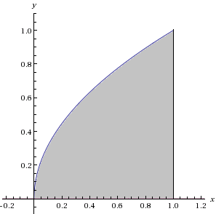
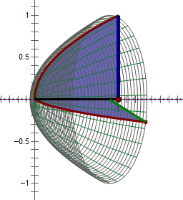
$$h$$
$$r$$
$$\left(1,1\right)$$
$$\left(1,0\right)$$
Since the shells stack up top to bottom, this problem should be done in terms of y. Because of this we need to solve our equations for x.

Setup:
We can see that and .
Therefore the volume of the solid is given by:
Evaluate:

Example 4: Find the volume when the region enclosed by the curves and is rotated about the line .
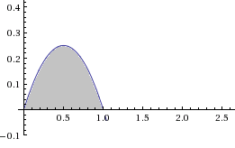
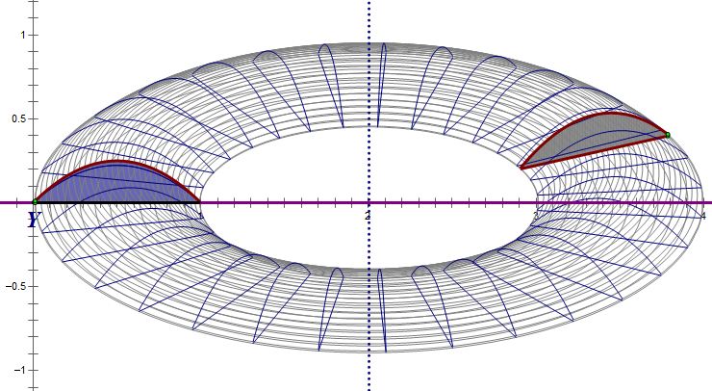
$$h$$
$$r$$

Since the shells stack up left to right, this problem should be done in terms of x.

Setup:
We can see that and . Therefore the volume of the solid is given by:
Evaluate:

